# A PROJECT REPORT ON

**ONLINE CRIME LOGGER**

**BY**

**Miss.Borhade Varsha Shantaram**

**Miss.Gadge Sanjivani Dnyaneshwar**

**Miss.Nimse Supriya Prakash**

Under the Guidance of

**Prof.Miss.Koshti D.R.**

**Prof.Miss.Wajage A.D.**

**Prof.Mr.Mandlik P.B.**

Submitted to the University of Pune

In partial fulfillment of the requirement

For the award of the degree

Of

**B.Sc. (Computer Science)**

**Academic Year 2013-14**

**Shivneri College of Computer Science, Ane**

**Shivneri Bahuddeshiya Sevabhavi Sanstha, Ale’s**

**Shivneri College of Computer Science, Ane**

**(Department of Computer Science)**

**CERTIFICATE**

**This is certify that Miss.Sanjivani Dnyaneshwar Gadge of Class T.Y.B.Sc (Computer Science) Sem. IV**

**Exam Seat No.:-**

**Has satisfactorily**

**Completed Academic Project**

**As prescribed by the University of Pune for the Academic Year 2013-14**

**Date:**

**Miss.Koshti D.R. Miss. Wajage A.D.**

**[Project Guide] [Head of the Department]**

**Internal Examiner External Examiner**

**ACKNOWLEDGEMENT**

It is our pleasure to be indebted to various people, who directly or indirectly contributed in the development of this work and who influenced my thinking, behavior, and acts during the course of study.

We express our sincere gratitude to Prof. Kahandal R.V.Worthy Principal for his guidance.

We are thankful to Prof. Koshti D.R. and Prof. Mandalik P.B. (Project Guide) for thier support, cooperation, and motivation provided to me during the Study of project.

We also extend my sincere appreciation to Prof. Wajage A.D.(HOD) who provided his valuable suggestions and precious time in accomplishing my project report.

We are also thankful my friends, colleagues and all our instructors for helping in the project.

Borhade Varsha.

Gadge Sanjivani.

Nimse Supriya.

**INDEX**

|  |  |  |
| --- | --- | --- |
| **Sr.No.** | **Name** | **Page No.** |
| **1.** | **Introduction** |  |
| **2.** | **Problem Definition** |  |
| **3.** | **Need of the System** |  |
| **4.** | **Scope of the**  **proposed System** |  |
| **5.** | **Requirement Analysis** |  |
| **6.** | **Feasibility Study** |  |
| **7.** | **System Database Design & Data Dictionary** |  |
| **8.** | **Diagrams** |  |
|  | * **Sequence Diagram** |  |
|  | * **Class Diagram** |  |
|  | * **Use Case Diagram** |  |
|  | * **Activity Diagram** |  |
|  | * **ER Diagram** |  |
|  | * **Package Diagram** |  |
| **9.** | **Screenshots** |  |
| **10.** | **System Testing** |  |
| **11.** | **Limitations of the system** |  |
| **12.** | **Future Enhancement** |  |
| **13.** | **System Specification** |  |
| **14.** | **Bibliography** |  |
|  |  |  |

**Introduction**

The project titled as “Online Crime Logger “is a web based application. This software provides facility for reporting online crimes, complaints, missing persons, show most wanted person details mailing. Any Number of clients can connect to the server.

This software reduces manual calculation and time of the Police station. It also helps to user to add FIR online.

The visitor only view hot news, missing person details, most wanted person.

Each user first makes their login to sever to show their availability. The server can be any Web Server.

Each of the station must first register with the Software. For the registration part each station enter their details like station name, address, phone no, station head etc. and get a User Id from the Software. Once the prospective station registers with the software they can avail the existing records.

**Problem Definition**

In the existing system only we can see the details of particular information about

The police stations in our state, the existing system has more workload for the authorized

Person, but in the case of Proposed System, the user can registered in our site and send the

Crime report and complaint about a particular city or person.

In existing system following problems are occur:-

* More man power.
* Time consuming.
* Consumes large volume of pare work.
* Needs manual calculations.
* No direct role for the higher officials.
* Damage of machines due to lack of attention.

**Need of the System**

The aim of proposed system is to develop a system of improved facilities. The system requires very low system resources and the system will work in almost all configurations. The need of the proposed system is to overcome the disadvantages of the existing system. The system provides proper security and reduces the manual work.

It has got following features:-

* Ensure data accuracy’s.
* Proper control of the higher officials.
* Reduce the damages of the machines.
* Minimize manual data entry.
* Minimum time needed for the various processing.
* Greater efficiency.
* Better service.
* User friendliness and interactive.
* Minimum time required.

**Scope of the Proposed**

**System**

Scope of the “ONLINE CRIME LOGGER “is as follows:-

The main modules in this project

* Visitors
* Registered Users
* Registered Station

**1. The visitor module includes:**

* View hot news: This module help the visitor to see the latest hot news which can updated by the station head.
* View Missing person: This module help the visitor to see the details like photo, name, address etc.
* View Most Wanted person: This module also help to visitor to see the most wanted persons details like photo, name etc.

.

**2. The registered user module includes:**

* Add Complaint: This module help the user to report online complaints.
* Add Crime report: This module help the user to report online crimes.
* Add Missing person: This module help the user to report online missing persons

Details also we have to add photos of missing person.

* View Missing persons: This module help the user to view all the missing person

Details.

* View Most wanted persons: This module help the user to view all most wanted

Persons which can be given by the station head.

* View complaint status: This module allows us to view the status of all complaint

That you have posted earlier.

* View crime status: This module allows us to view the status of the all crimes that

You have posted earlier.

**3. Registered Station module:**

Each of the station must first register with the Software. For the registration part each station enter their details like station name, address, phone no, station head etc. and get a User Id from the Software. Once the prospective station registers with the software they can avail the existing records. The Registered station module may contain following sub modules:

* View Crime description: A station can view crime description of any crime from the database.
* View Criminal Details: A Station can view criminal details from database.
* Add FIR: A station can add FIR after complete verification.
* New Team Register: A station can add new team to the database.
* Add New Team Member: A station can add a new team member to existing team.
* View Witness details: A Station can view witness details added by a user during crime description.
* View Victim details: A Station can view victim details added by a user during crime description.
* View Arrest details: A Station can view arrest details added by a user during crime description.

**Requirement Analysis**

Requirement analysis produces in the specification of software’s operational characteristics:

* It indicates software interface with other system element.
* It establishes constraint that should accomplish.
* Requirement analysis provides information, function & behavior that can be translated into architectural interface & component level design.
* This translation is performed during construction of analysis model.
* It includes:
* It decides and adds all important function which is maintained in the requirements.
* It decides and adds important function which is not maintained in the requirements, but it is essential to build.
* It defines all interfaces of the software to be developed.
* This analysis model is very helpful for establishing the design model.

**Feasibility Study**

This being hypothetical system, the feasibility study states simply the specification and assumptions about the organization.

The following aspects state the points that were considered while the feasibility study was undertaken.

* **Operational Feasibility:-**

All the procedure followed in this system are standard. The system merely proposed to automate the working, manual system without making any new addition to the procedural details.

Hence the system is speculated to remain operational for quite same time and definitely long after it development cost has been returned.

* **Economic Feasibility:-**

Expenses to be considered are for machine costs and software development. No new employees need to be recruited. Only adequate training is needed to be given to people currently employed and those who would be using the system maintenance are negligible.

* **Technical** **Feasibility:-**

The technical aspect of the system consists of one machine at each side at every branch counter.

**System Database Design &**

**Data dictionary**

**Table Name: User Details**

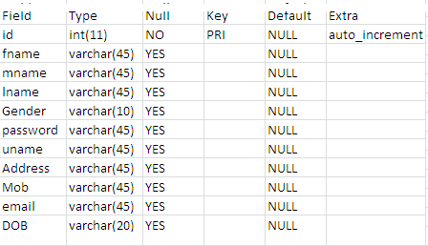

**Table Name: User Login**

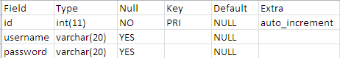

**Table Name: Station Details**

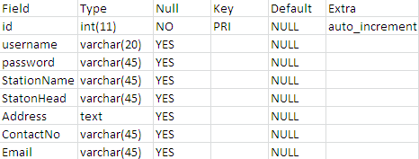

**Table Name: Crime News**

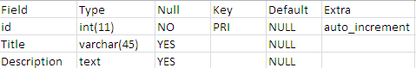

**Table Name: Arrest Details**

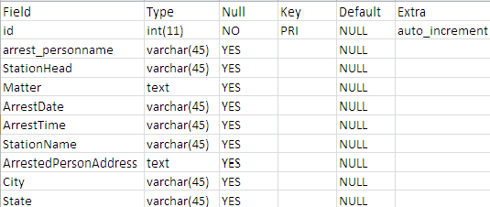

**Table Name: Criminal Details**

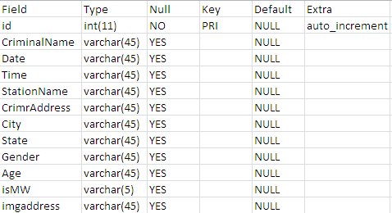

**Table Name: FIR Details**

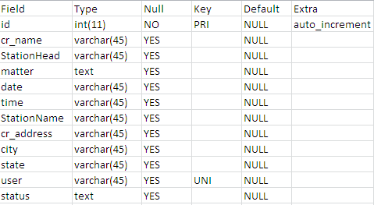

**Table Name: Missing Details**

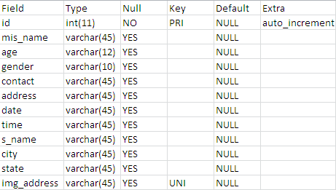

**Table Name: Victim Details**

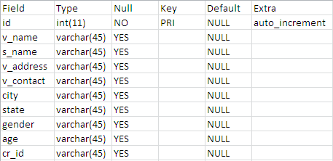

**Diagrams**

**Sequential Diagram:**









**ER Diagram**

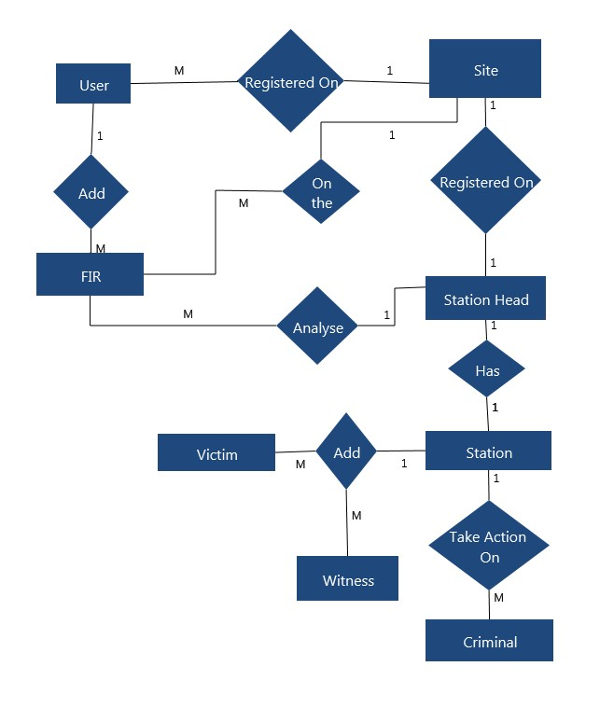



**DFD Diagram:**

**Level 0 DFD(User Login)**

Login r Request

Users

Crime report

Details Response

**Fig Level 0 DFD for User Login**

**Level 1.1 DFD (registered user)**

Visitor

Login

Request details

Username

Password

Crime description

Details

**Fig Level 1 DFD for Registered User**

**Level 1.2 DFD (registered station)**

Station

Login

Request details

Username

Password

Details

Criminal details

Newteamregister

Witness

Victim

Team member

Crime close

Crime description

Crime description

Request

Details

Fig Level 1 DFD for Registered Statio

**Screenshots**

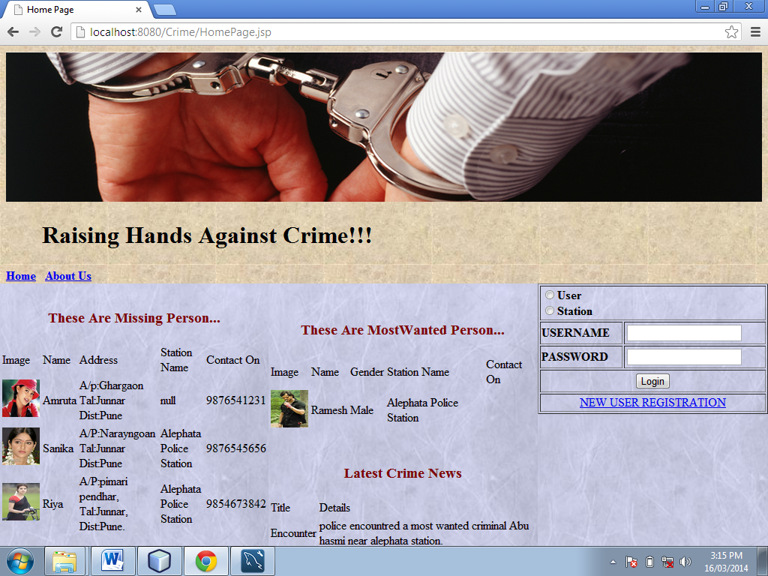

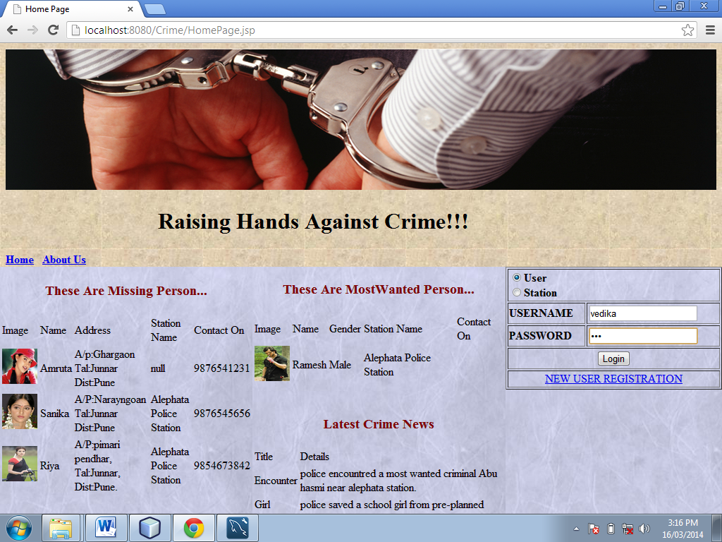

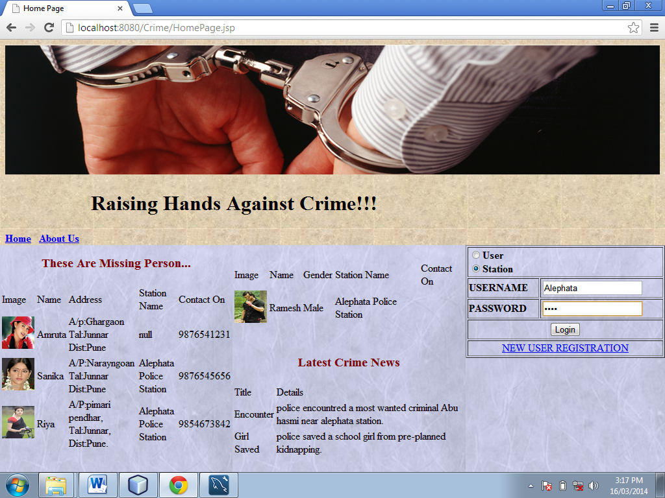

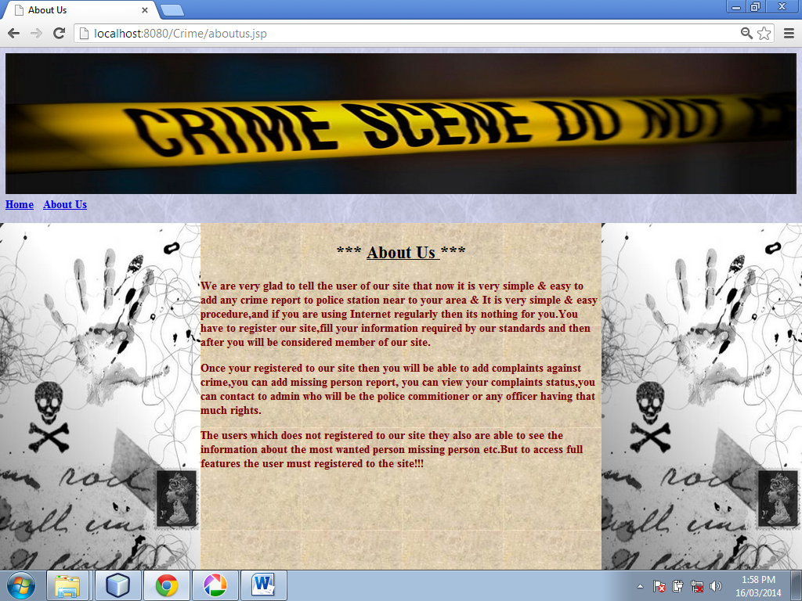

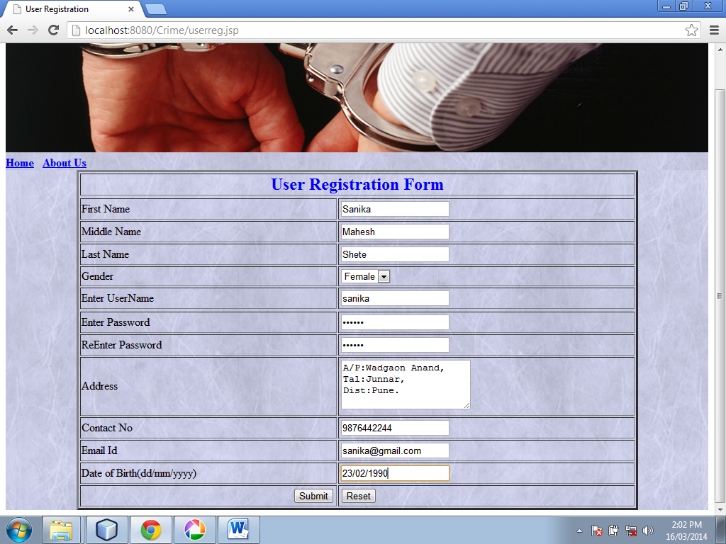

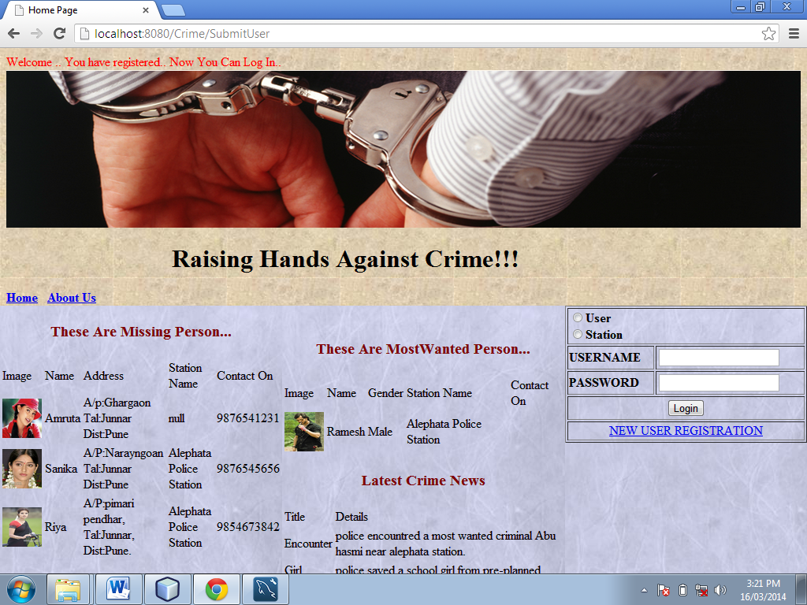

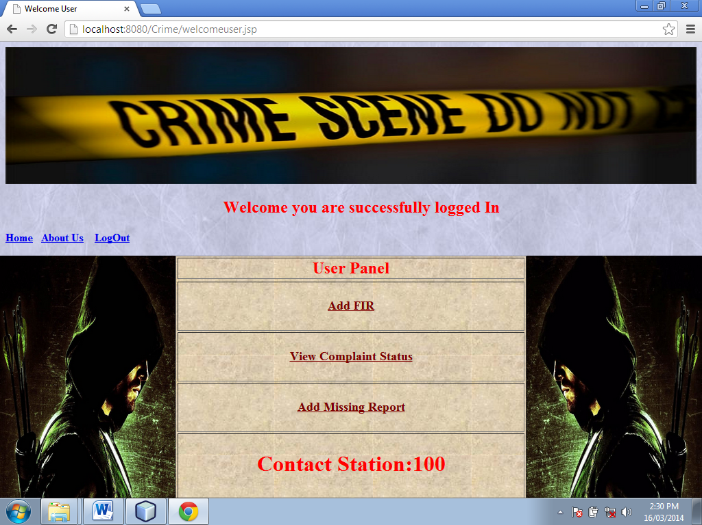

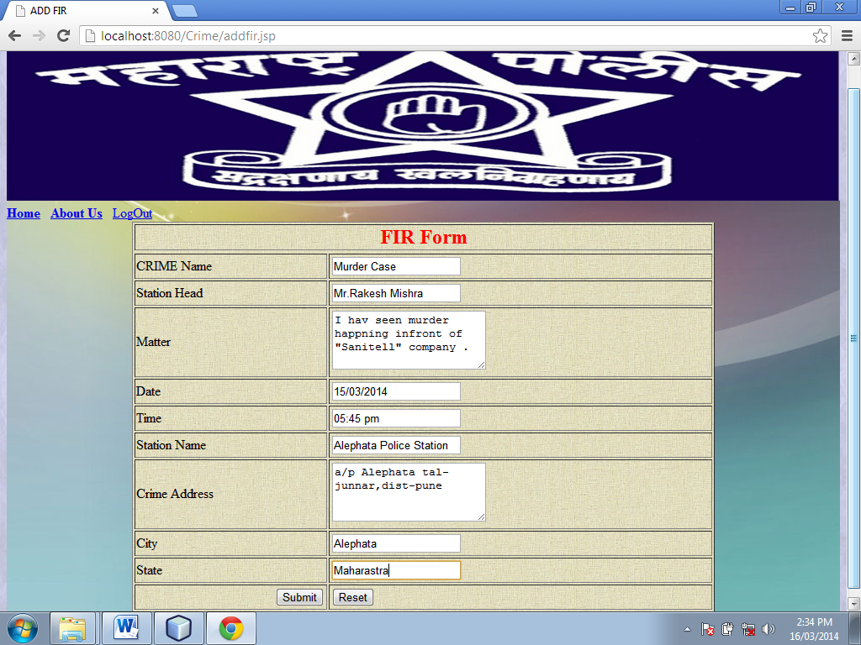

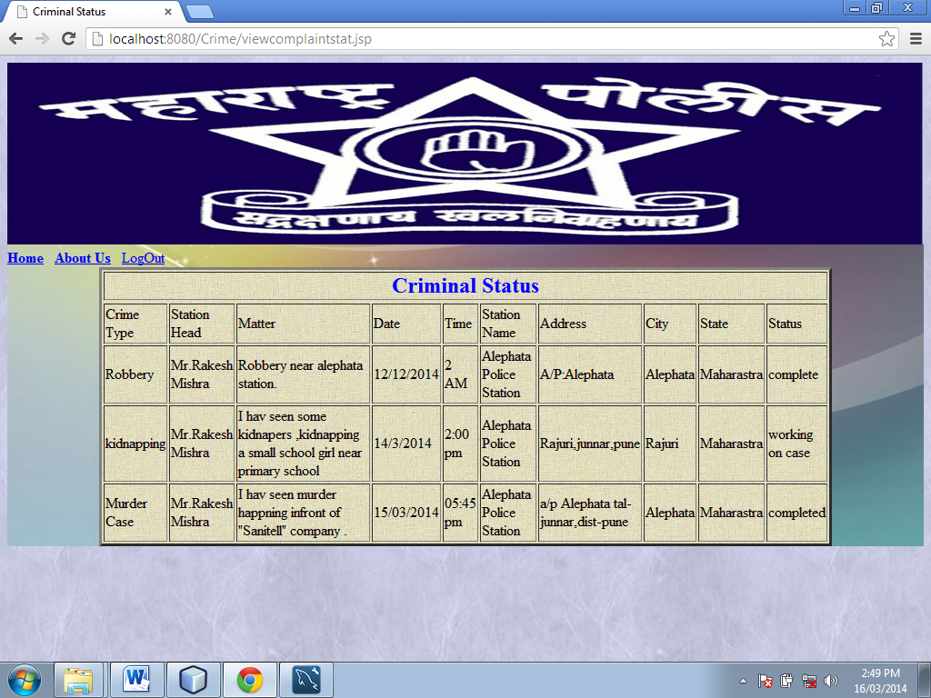

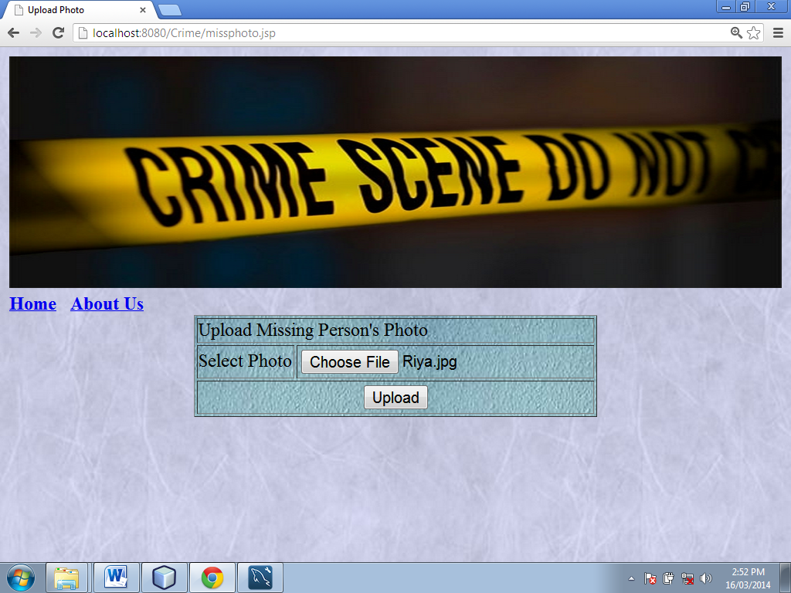

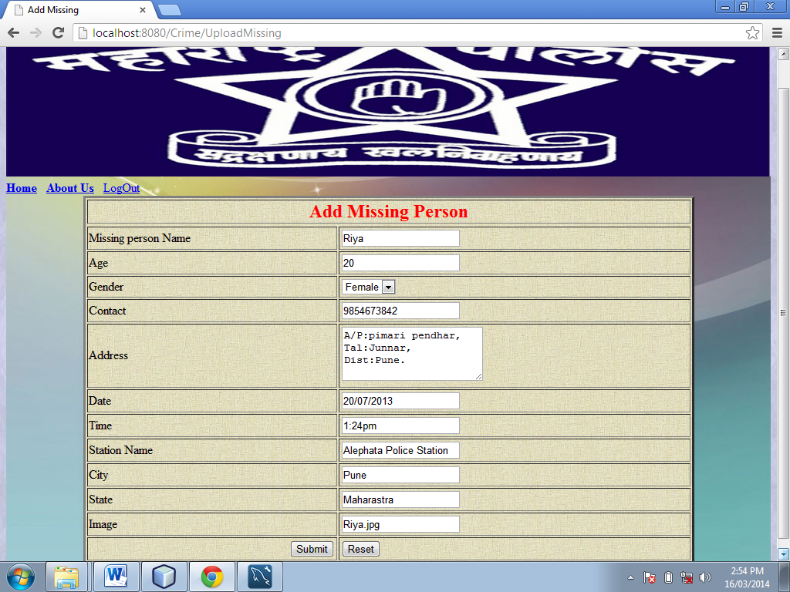

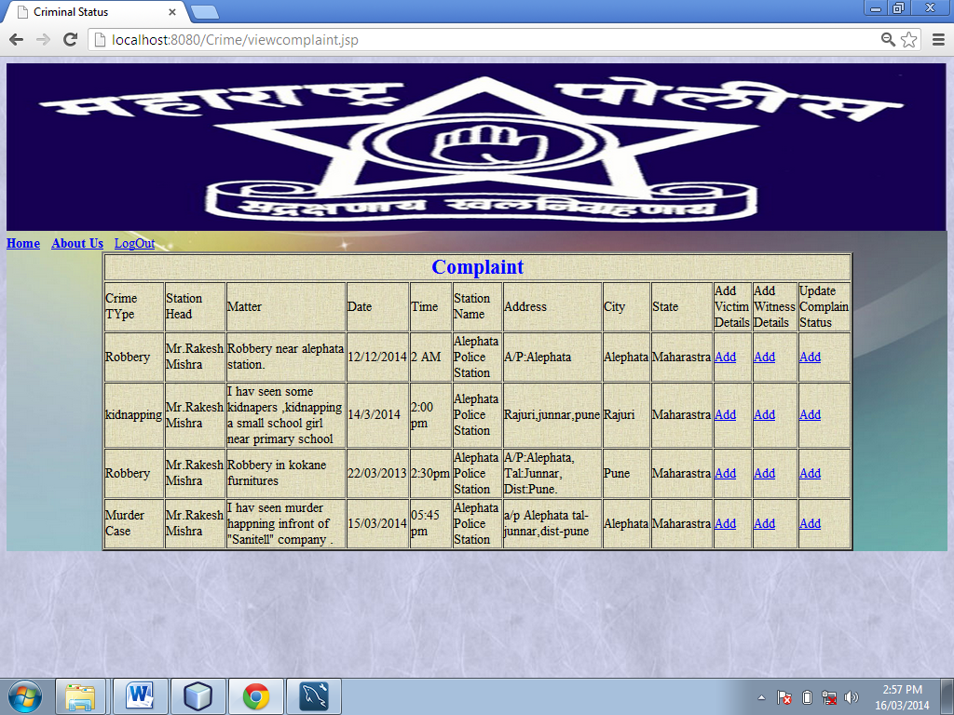

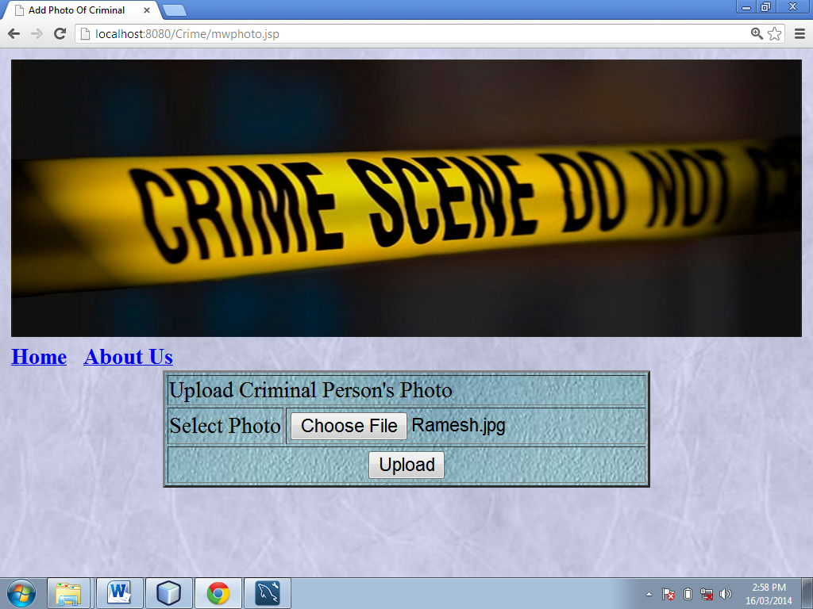

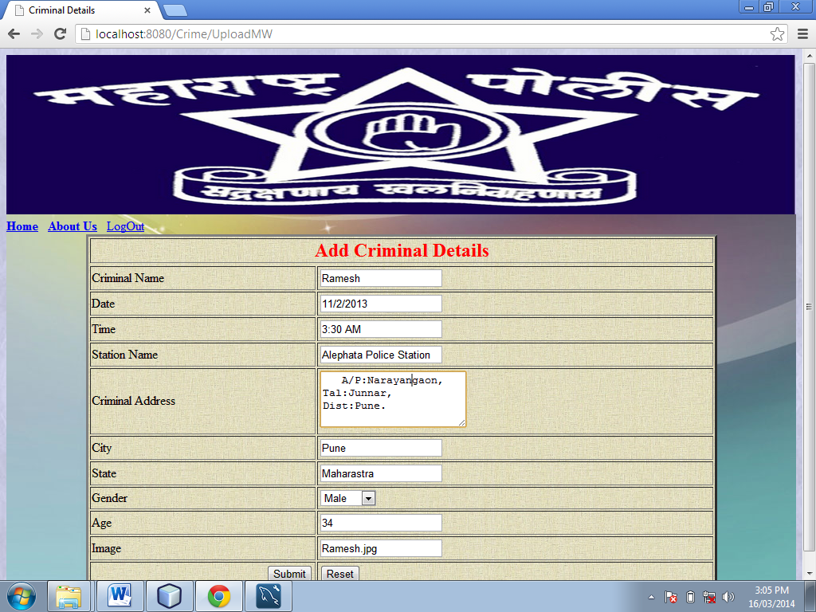

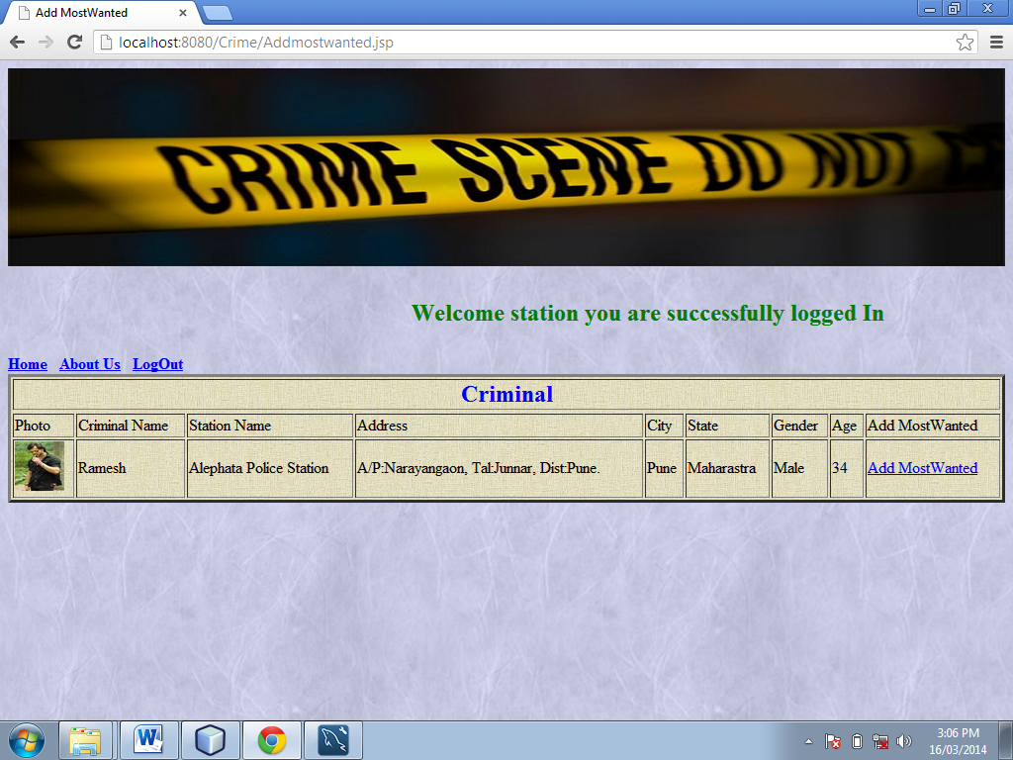

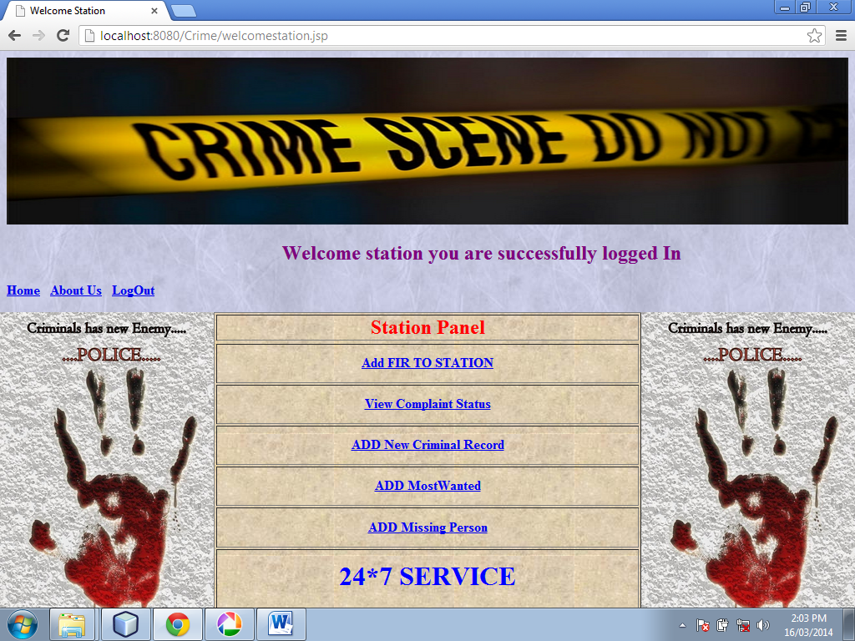

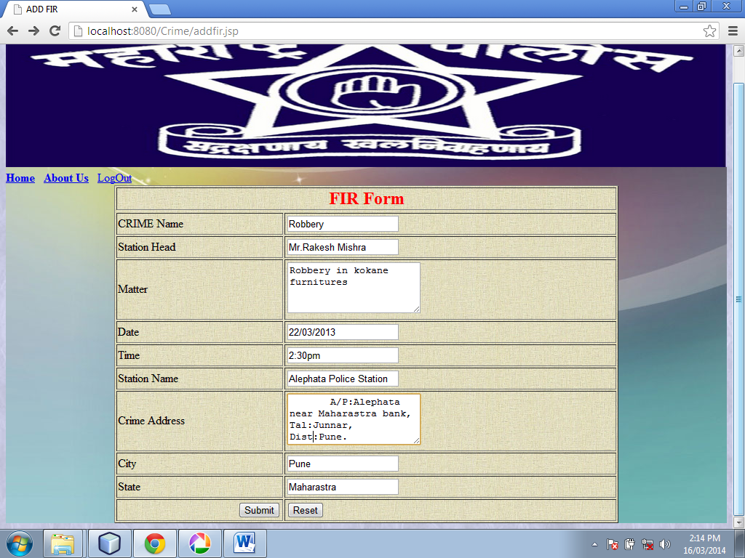

**System Testing**

* The system was tested with usual test routines with the intent of finding an error to detect bugs and to test the quality of the software.
* There are three main kinds of system testing:-
* **Alpha testing** was conducted at the developer side by the end users.
* **Beta testing** was carried out by the selected group of friendly customers, conducted at the end user side.
* **Acceptance testing** was performed by the customer himself to determine whether the system should be accepted or rejected.
* The system begins its first test by **unit testing** one & only one unit is tested as such.
* Testing procedures were carried following the **Bottom-up testing approach**. According to the Bottom-up approach each unit is tested as and when it developed. This units are combining into modules are also individually tested. And finally all the modules are integrated to form the entire system.
* **Integrated testing** is then performed on this developed system.
* An entire code is return in java. The system is object oriented. Thus the entire code is encapsulated into classes so it was easy to perform the testing procedure system was developed progressively taking one module at a time. Finally when all the modules were ready they were integrated to form the entire system.
* Finally when all the modules were integrated and the entire system was ready, I/O testing, performance testing and stress testing was carried out to test for all the conditions, exception handling capabilities, etc.
* **Input/output testing** was carried to check whether the system generated consistent files of the desired format. Also Input / Output testing helped to confirm whether the files were successfully uploaded at the server or downloaded from the server.
* **Performance testing** was carried out to test the real time performance of the software and to check whether the system could handle exceptional conditions efficiently.
* **Stress testing** was carried out to check the system performance when too many users were logged on to the system at the same time.
* **Errors and Exception** detected during testing phase were removed; also minor modifications were also made to make the system more robust. The test results were found to be fairly good.

**Limitations of the system**

* This site is not available for mobile application.
* Now this site works for only one station.
* Actions can taken locally only.
* User will be local for particular station.

**Future Enhancement**

* We can update this system as online application.
* The main advantage of online application is that, a person can report the crime anytime from anywhere.
* Users can view the progress of their complaint online.
* By the future technology user can view the case details and progress of the complaints on their mobile phones.
* Face recognition technology can apply. User or witness of the crime can give the physical information of the thief.

**System Specification**

**Software Specification:**

* Operating System : Linux(Unix)/Windows 7
* Languages : Java
* Front End : HTML
* Platform : Java script
* Web Servers : Glassfish Server
* Backend : My SQL(Server 2012)
* Browser Program : Internet explorer/Mozilla Fireworks

**Hardware Specification:**

* Processor : Pentium III onwards
* RAM : 128 MB
* Hard disk : 40 GB OR more

**Bibliography**

1. Software Engineering

Pressma.

1. HTML & Web Design

Kris Jasmsa

Konrad King

Andy Anderson

**ONLINE REFERENCE:**

* [www.wikipedia.com](http://www.wikipedia.com)
* [www.w3schools.com](http://www.w3schools.com)
* [www.seminarproject.com](http://www.seminarproject.com)